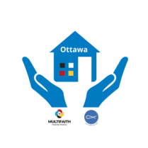 Society of Saint Vincent de Paul of Ottawa
and
Multifaith Housing Initiative
AFFORDABLE HOUSING Golf Tournament (Best Ball format)
at the Pine View Championship Golf Course, Monday, August 28th, 2023
Registration Form
Payment due August 12th, 2023 ($140/person)
If you cannot provide a foursome, you will be grouped with other players.
Team Contact Information
Name _________________________________ Entry Fee Due $________________
Phone # _______________________Email:_______________________________
For issuing Income Tax Receipt
Players Name | Address | Email

I can't golf but I will make a donation of $________________
I would like to sponsor this event, please email me details _______
Please email your registration form and electronic payment to:
SSVPgolf@gmail.com or contact Brian Miller by phone 613-225-7745,
or mail your form and payment (cheque payable to “SSVP Ottawa Central Council”) to:
SSVP Ottawa Central Council 19 Bowhill Avenue, Ottawa, K2E6S6.
Teams for whom we have not received payment by August 12th, will forfeit their spot if there is a waiting list.
For more information on our Housing Initiative, check out ssvpottawa.ca

